PRESIDENT’S MESSAGE
Well thanks to late rains, our drought has moderated and there will be some water for our forests and gardens. Every drop and flake is welcome and appreciated. Today, I am looking out our window in Sacramento and seeing lovely wet clouds and light rain.
Forest news has been arriving steadily. The CUFFA effort seems to have floundered on the rocks of revenue and politics. This is good news for those of us in the lower value tiers of the proposed law and less good for those with the highest appraised values.
Logging and vegetation removal “proximate” to cabins continues under FS programs euphemistically called “forest health” and “habitat improvement”. I am of two minds about these projects because of the long term disruption caused by removing large trees from the forest ecosystem. Yet we understand the need to “manage” our forest and reduce fire danger from ladder fuels. Yet the incentives are suspect as we subsidize fire management by selling market logs and wood chips to power plants. The proper balance is complex as the reasonable person will be the first to admit.
Even with our late season snow, we face another season of low rainfall and high risk of fire. The recreational officers of the various districts may turn their focus to water rights and supply systems but

this is a conversation for those tracts which face the issue. We must all be very careful with outdoor fires and stack screening because one spark will change the landscape for our lifetimes.
My final thought is that we should encourage the FS to provide the type of recreational amenities that are low impact and serve the wider public. Current Federal budgets are inadequate for the task and we need to assist our government where we agree on policy objectives. As recreational infrastructure ages, we as an association should be willing to financially contribute to see tract signage, bridges, roads, and footpaths replaced with quality renovations and improvements. We can be both critics when necessary and good stewards because in the end it is our forest to enjoy and protect.
s/ Hal Thomas President NSSHA

THE NSSHA GENERAL MEETING WILL BE HELD AT THE SCIOTS CLUBHOUSE ON JUNE 21, 2014
AT 10 A.M.

Back by popular demand,
the Cody Boy Scouts will again lead
the Pledge of Allegiance at the beginning of our meeting.
~~~~~~~~~~~~~~~
Dues remain at $20 and should be sent to: NSSHA c/o Tony Planchon,
1768 11th Avenue
Sacramento, CA 95818

HISTORY OF THE ECHO LAKE WATER DIVERSION
by Kathy Lewin
Water from Echo Lake didn’t always flow down the American River as gravity and nature sent water into the Tahoe Basin. In 1856, John Kirk, an engineering consultant from Pennsylvania, came to Placerville and claimed the waters of the South Fork of the American River.
With this beginning, he initiated what we now refer to as FERC Project 184, a vast water storage and conveyance system that includes Lake Aloha, Echo, Silver and Caples Lakes that funnels water from the high Sierra into the American River to fill the reservoirs and lakes that provide water to summer streams and millions of people.
What began as a water to remove gold more easily from placer diggings, became a major supplier of irrigation to the ranchers and growers in the region. Around the late 1800’s, the concept of generating hydroelectric power was born and a company named American River Electric Company completed their first facility on the South Fork American River. They sold this project to Western State Gas and Electric (fore runner of Pacific Gas & Electric) in 1910.
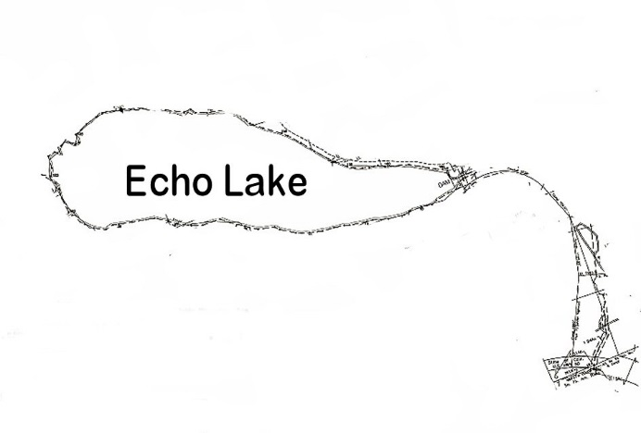
Figure 1 - Highway 50

What began as El Dorado Water Company in 1919, ultimately became the El Dorado Irrigation District in 1925 – voted into existence by an increasing

demand for reliable water to keep pace with the growing population. They completed Sly Park Reservoir in 1955 with plans to build a dam at Folsom.
The outflow of the diversion from Echo Lake starts at the south end of Lower Echo, controlled by a dam with a levered, metal gate that can be raised and lowered as water level demands. From the dam, there are a series of canals and tunnels that run parallel to Echo Lake Road behind Berkeley Camp. The water is then piped under Highway 50 at the old Little Norway, into Audrain Meadow, where it becomes the head waters of the South Fork of the American River.
Map (modified to show canal/tunnel project) provided by Tammy Feryance, Records Management and Admin Supervisor for El Dorado Irrigation District. Information provided by Dan Gibson and Steve Lindstrom, employees of the El Dorado Irrigation District as well as the website for EID.

A NOTE FROM JIM BOTSFORD REPRESENTING SILVER LAKE AND KIRKWOOD

Our 11 cabins at South Silver Lake accepted the second appraisal lowering our value from $65,000 to $60,000 and reducing our annual cost by $250 per cabin. Some wildly expensive properties were sold in Southern California which altered the base values described by our appraiser. We are grateful to the NSSHA for the grant which made the process more affordable for the cabins that participated in the second appraisal. Kirkwood Lake is going to the next step in appealing their appraisal to the Forest Service. Kudos to Lyle and his professional expertise!

PHIL OAKES MEMORIAL SCHOLARSHIP

This project has come full circle. After Phil passed away in August 2012, the Board decided to fund a memorial scholarship. Motivated by Phil’s love of fly fishing and the mountains, it was decided that our own Cody Lake Boy Scouts Troup encamped at the base of Cody Meadow would receive scholarship funding to enable a couple of boys to enjoy the high country.

Now in its second year, the NSSHA Board has voted to donate $500 in Phil's name for two boys to attend the camp each summer. In March 2013, Kathy Lewin attended the Cody Lake Troop 1 meeting and presented the troop with the

gift. Below is Troop 1 in front of the Oakes cabin at Wrights Lake before hiking into Desolation to earn their
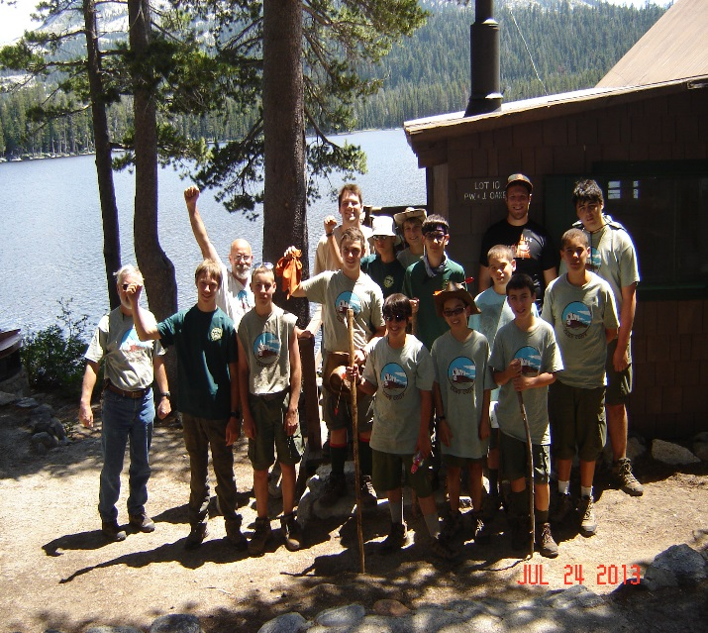
fishing/wilderness merit badges.
A QUICK NOTE FROM APPRAISER, LYLE WILKINSON
I have done second appraisals for the typical lots at Dark and Wrights Lakes. These have not been approved by Kim Brower, Regional Appraiser, as of this date (March 11, 2014). I also did second appraisals for Lake Kirkwood and one typical at Silver Lake. My appraised values were all slightly lower than the first appraisals. I don’t know what the final decisions will be on the values used to determine the fees. The decision maker can choose to go with the first or second appraisal – or something in between. My recommendation is to meet and work with the District Ranger to secure the most favorable decision.

CABINS BURGLARIZED NEAR PLASSE’S RESORT by David Dirkes from Ledger Dispatch January 31, 2014
The Amador County Sheriff’s Office is investigating a string of burglaries near Mud Lake Road and Plasse’s Resort. An initial report, filed January 13th, outlined a series of reported break-ins in the area around Tragedy Springs. Tracks from the scene led the ACSO to 18 other cabins that had been targeted in the short spree. The investigation also revealed that someone had rammed a gate on Plasse Road, where some of the stolen items were located nearby in nearby brushy terrain on January 15th, two days after the initial report. Among the items recovered were a shotgun, bicycles, tools and a backpack full of miscellaneous items. A stolen Snow Cat, which had left a trail for ACSO investigators to follow toward Plasse’s Resort, was recovered a short time later, with its engine still warm. More ACSO personnel were called in, including a K9 unit and crime scene technician, to search the area. Unfortunately, no one was located, but latent fingerprints and DNA were recovered during an ensuing three day search. A total of 19 cabins were found to have been burglarized or showed evidence of an attempted break-in. Food, alcohol, batteries, flashlights, blankets, backpacks, clothing and four small generators were also stolen. The investigation remains ongoing and it’s still

unclear how many burglars there may be. Anyone with information regarding the burglaries is asked to contact the ACSO at (209) 223-6500 or the Amador County Secret Witness at (209) 223-4900.

ENFIA WALKER PROGRAM
In 2007 a new program of service was added to the ENFIA (Eldorado Nation Forest Interpretive Association) Carson Pass program. Docents trained and involved at the Carson Pass Information Station (CPIS) walked the trails in the Mokelumne Wilderness and surrounding areas including the Meiss country (LTBMU) and the Pacific Crest Trail. The ENFIA volunteers. became the “eyes and ears” for visitors in the field available to answer questions and to provide aid. It has been a very popular program and ENFIA is proposing to expand and formalize the Walkers Program. The association is looking for volunteers interested and available to help out on the Amador, Placerville, Pacific and Georgetown Ranger Districts on the Eldorado National Forest. Volunteer activities will be coordinated with individual district liaisons in order to meet the specific priorities of each district. Safety training and uniforms will be provided by ENFIA. If you are interested in joining our group, please call either: Kathie Piaszk (530) 295-0700 or Dawn King (530) 944-3149 between 10 a.m. – 8 p.m.

