President’s Message
Fire and Water
Our cabin lives involve the Forest Service whose personnel administer our special use permits and whose oversight can make our lives richer or poorer. Richer when the forest is safe and the cabin community orderly and well maintained. We become poorer, when the arbitrary application of rules is discriminatory or irrational. We know through years of experience that our permit administrators swing between benign neglect and micro management. We know time and personnel change but the pendulum swings at a pretty constant rate.
This year the issues we must consider are fire and water management. Cabins need sufficient water including the water pressure to deal with fire, be it to extinguish the charcoal briquette that falls to the ground or to stop a chainsaw spark from becoming a major fire. We know drought is restricting our water supply and the cabin season may be shortened by the lack of water. The logical response is to improve water storage and increase reserve water pressure for incidental fire suppression. Yet, the FS treats replacement or expansion of water storage capacity as a new installation requiring a complex “discretionary” approval. Similarly the FS has unilaterally narrowed the definition of cabin “maintenance” so that more discretionary approvals are being imposed on cabin owners for such traditional activity as replacing existing decks, sheds, and other facilities.
This close, arbitrary, and at time invasive micro management of what are permitted activities is unreasonable. Yet repeated attempts to bring these issues to the Forest Supervisor have been unsuccessful. Telephone calls are either not returned and requests for meetings go unanswered. Last year the Forest Supervisor was invited to attend our annual meeting and failed to appear.
Those who have been unable to repair water systems or make basic cabin improvements might ask the following. In the middle of the fourth year of a desperate drought is the color of the tarp, the paint color of the shed, or the diameter of the water pipe issues that should keep FS management up at night? It is time for what we call the rule of reason to be applied to basic health and safety issues.
s/ Harold M. Thomas President NSSHA

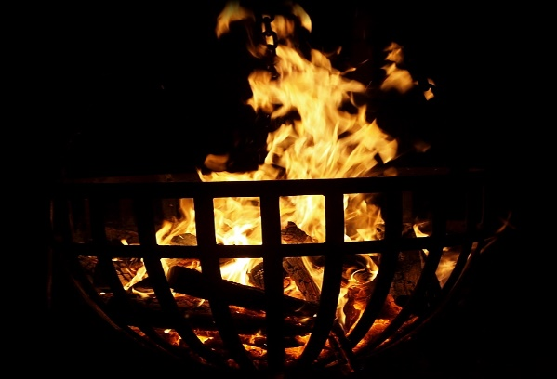

Drought News - Curtailment Orders Pending
In the summer of 2014 the California Water Resources Control Board (SWRCB) issued water right curtailment orders impacting all junior water rights holders in the Sacramento and American River Watersheds. This order restricted the right of most if not all cabins from diverting water from the creeks and streams that are within the Eldorado National Forest. In fact, the order did little to increase water supply because the amount of water diverted by cabin owners is almost insignificant in light of the senior diverters and others whose rights were being impaired. Secondly, the State’s informal practice of enforcement against larger diverters spared the small domestic users because in a rational world the cost benefit of enforcement against seasonal domestic cabins is expensive and yields little additional water supply. Our leadership did appear at the State curtailment hearings and were told the rules would apply to all without exception.
It appears that the same program will be imposed this water year. On January 33, 2015 the SWRCB issued a notice to potentially curtail junior water rights. In March the SWRCB passed regulations to implement drought control programs. Today the SWRCB website indicates that curtailment orders for the Sacramento River Watershed (which includes the American River) is pending. The best we can say is rainfall is short, snow has gone missing, and in the near future curtailment orders are likely.
WILD FIRE AND THE NEIGHBORHOOD
South Fork American River Cohesive Strategy Project
The Eldorado National Forest is implementing a wild land fire management policy that will have significant effects on those recreational residences (aka cabins) located on the South Fork of the American River down canyon from Twin Bridges. The specific planning for the canyon is called “Fire Adapted 50” and the project proposes “larger fire adapted fuel breaks”. While in concept this may be important the devil is in the details particularly if your cabin once in the forest has been designed for life in the fuel break. Specifically watch for details on two projects including logging three hundred feet of the north side of Hwy 50 from Pollock Pines to Strawberry and the “Road Runner” wild land urban interface project from Strawberry to Twin Bridges.
Some critics including this writer having lived through successive forest “hazard tree removals ”power line clearance removals” and now “ urban interface forest thinning” , see these efforts as more or less continual large tree removal extending over decades. Some forest thinning and undergrowth removal is important but off season low intensity understory burns would be economically and ecologically more effective. Removal of large trees proximate to cabins is unreasonable and often disruptive to property values.
Lastly NSSHA has not received any invitation to consult on the details of these efforts except the now standard website notice.
THE PHIL OAKES MEMORIAL SCHOLARSHIP
Three years ago, when founding member Phil Oakes passed away, our membership decided to honor Phil in way that would extend beyond our daily memories of his good work.
Many ideas were discussed but the final choice was to fund a scholarship so that boy scouts from Sacramento Troop One could attend summer camp up at Cody Lake.
This scholarship has served several purposes.
First of all, Phil was an avid fly fisherman who loved spending time with his family at their cabin on Wrights Lake. This scholarship gives the boys an opportunity to earn merit badges for all types of wilderness activities including hiking, fishing, camping and other outdoor experiences. Phil would have loved making that available to them.
Secondly, it fulfills an opportunity for boys whose parents might not be able to afford the whole cost of the camp to enable these young men the unique experience of learning outdoor recreation, survival skills, self-reliance, teamwork and an appreciation for the wilderness environment.
In the last several years, the Troop One Color Guard has opened our annual meetings at Sciots Camp. It is their way of saying “thank you” to the NSSHA for our generosity and commitment to the human community that uses and loves the high county.

NSSHA GENERAL
MEMBERSHIP MEETING
JUNE 20, 2015 at 10: 00 AM at the Sciots Clubhouse with opening ceremony provided by the Cody Lake Boy Scout Troop One Color Guard.
Dues remain at $20 and should be sent to:
NSSHA c/o Tony Planchon, 1768 11th Avenue, Sacramento, CA 95818 ~~~~~~~~~~~~~~~~~~~~~~~~~
OFFICERS:
PRESIDENT – HAL THOMAS (916) 736-3169
VICE PRESIDENT – JIM BOTSFORD (209) 887-3761
SECRETARY – NANCY ALLEN (530) 626-8955
TREASURER – TONY PLANCHON (916) 441-6060
EDITOR/WEBMASTER – KATHY LEWIN (916) 481-6527
NFH LAIASON – MARY VER HOEF (916) 801-1134
SUPER TRACT REPS:
AREA 1 – RANDY SIMIN (916) 967-0397
AREA 2 – NORM ALLEN (916) 786-6389
AREA 3 – LINDA OLSEN (916) 429-2664
AREA 4 – DAWN KING (530) 644-3149
AREA 5 – JENNIFER LANE (916) 985-4555
AREA 6 – MARY VER HOEF – (916) 801-1134
AREA 7 – JIM BOTSFORD (209) 887-3761
AREEA 8 – NANCY ALLEN (530) 626-8955
AREA 9 – KATHY LEWIN (916) 481-6527

